COURSE CERTIFICATE

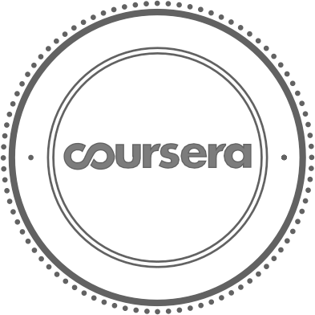

02/4/2025

Rahul B C

O

R

E

O

N

F

has successfully completed

V

E

R

Y

O

U

C

A

T

I

Improving Deep Neural Networks: Hyperparameter tuning, Regularization and Optimization

U

O

N

C

E

E

D

E

T

A

an online non-credit course authorized by deeplearning.ai and offered through Coursera

E

C

E

S

R

C

I

F

I

T

R

Adjunct Professor Andrew Ng Computer Science

Verify at coursera.org/verify/RRNQKV8SV6X2

Coursera has confirmed the identity of this individual and

their participation in the course.